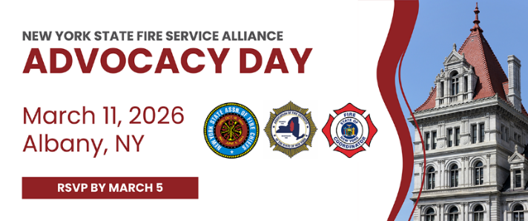
2026 New York State Fire Service Alliance Legislative Agenda
1. Volunteer Firefighters’ Benefit Law (VFBL) Coverage – S.5432/A.6410 (Skoufis/McMahon)
Should be upgraded to align more closely with the protections and benefits of workers’ compensation. Enhancements might include higher weekly rate reform rates for injuries, coverage for mental health and illness arising from service, and streamlined claim processes. This ensures volunteers receive equitable protection compared to paid personnel.
2. Designate EMS as an Essential Service – Chapter 703 of the Laws of 2025
Emergency Medical Services (EMS) should be legally recognized as an essential public service, similar to police and fire protection. This ensures stable funding, mandatory service coverage in every community, and access to state and federal resources. Making EMS essential would also strengthen workforce support and improve response times, particularly in rural or volunteer-dependent areas.
3. First Responder Peer Support Act – S.5407-A / A.7285-A (Harckham/Burdick)
This act would establish or expand peer support programs for firefighters, EMS personnel, and other first responders. It provides confidential mental health counseling, training for peer mentors, and protection for support communications under the law. The goal is to address stress, trauma, and burnout, improving overall mental health and job performance.
4. Continue to Improve Tax Benefits for Volunteer Firefighters and EMS – S.6233/A.6790 (Martinez/McMahon)
Enhancing state and federal tax incentives, including increasing income tax relief and allowing firefighters to receive both real property and income tax benefits.
5. Fire Service Nominal Compensation – Legislation Proposed To Be Introduced
Allow fire districts and departments to offer modest compensation to volunteer firefighters to support recruitment, retention, and staffing. This would strengthen, not replace, volunteer service, while ensuring LOSAP and VFBL protections remain in place under existing FLFA guidelines.
6. Amendment to the Ambulance Billing Law – Originally Enacted in Chapter 55 of the Laws of 2022 and Extended by Chapter 57 of the Laws of 2025
This amendment authorizes billing for mutual aid responses, allowing EMS providers to recover costs and eliminating prior restrictions on mutual aid billing. The law is scheduled to expire on April 9, 2031.
7. Retirement Service Credit – S.7021/A.8082 (Ryan/Eachus)
Volunteers and part-time emergency responders could earn service credits toward pension or retirement systems based on their years of active duty. Seeking to provide 1 year of service credit for the State Retirement System for every 5 years of volunteer fire service, with a maximum of 3 years of credit. Adding or improving retirement credit eligibility provides long-term recognition and financial stability for those who dedicate their careers or extended volunteer service to public safety.

8. Executive Proposal of Health Budget Bill Part M – Elimination of Crossover Payments
The crossover payment ensures that ambulance providers receive reimbursement for the remaining balance of Medicare-approved services for patients who are dually eligible for Medicare and Medicaid. Fire departments deliver EMS services regardless of a patient’s ability to pay. Removing the payments would shift additional financial strain onto local fire departments and municipalities, potentially impacting their ability to sustain emergency response services.

